Sample: DB6, Carolina bay inner basin

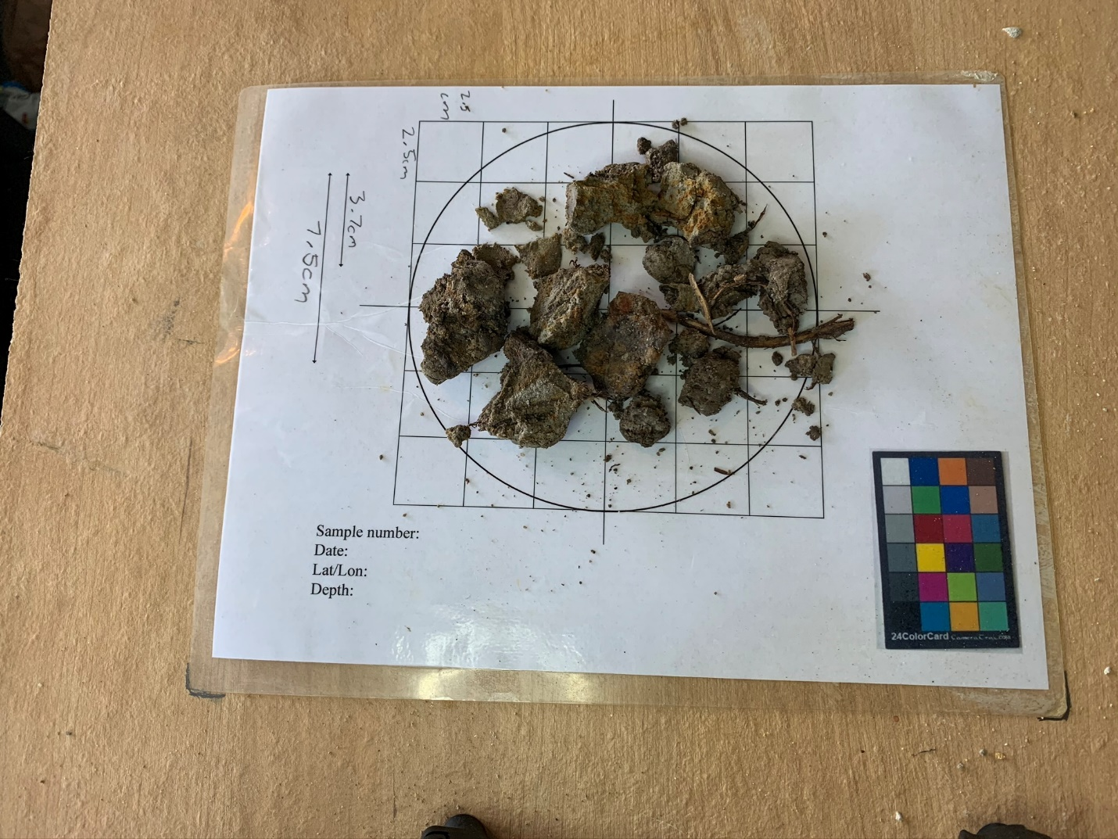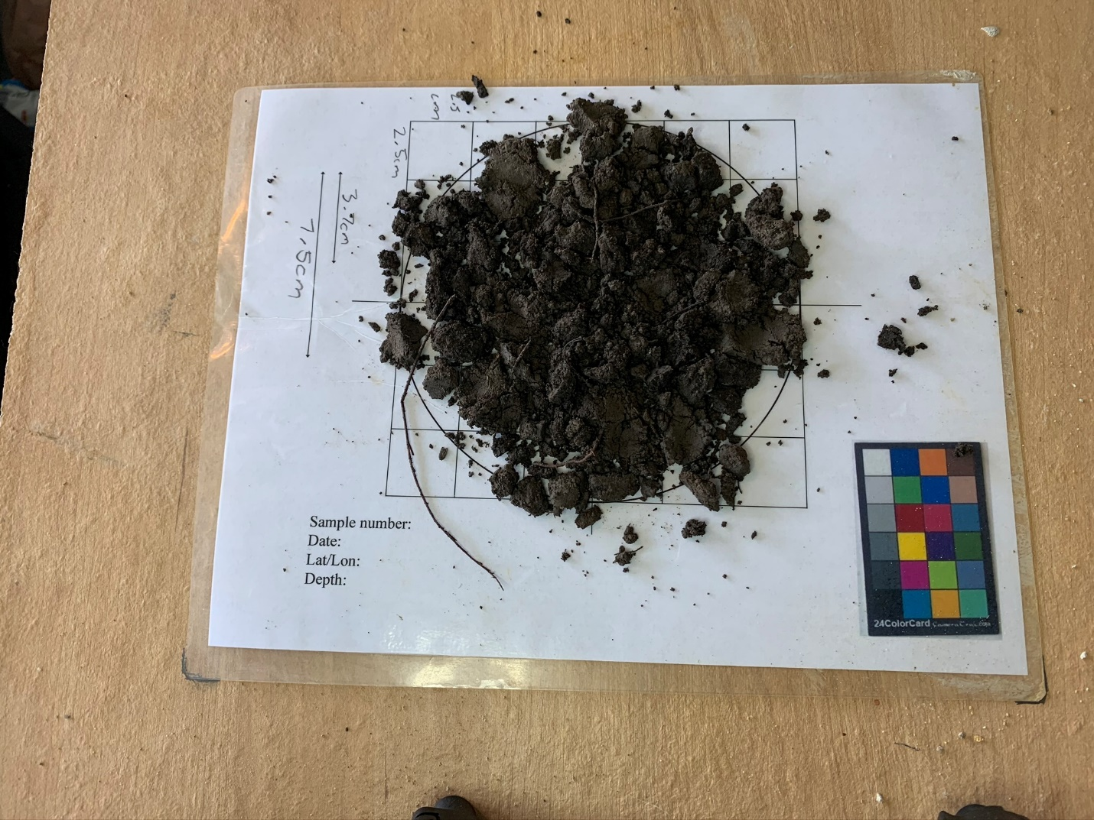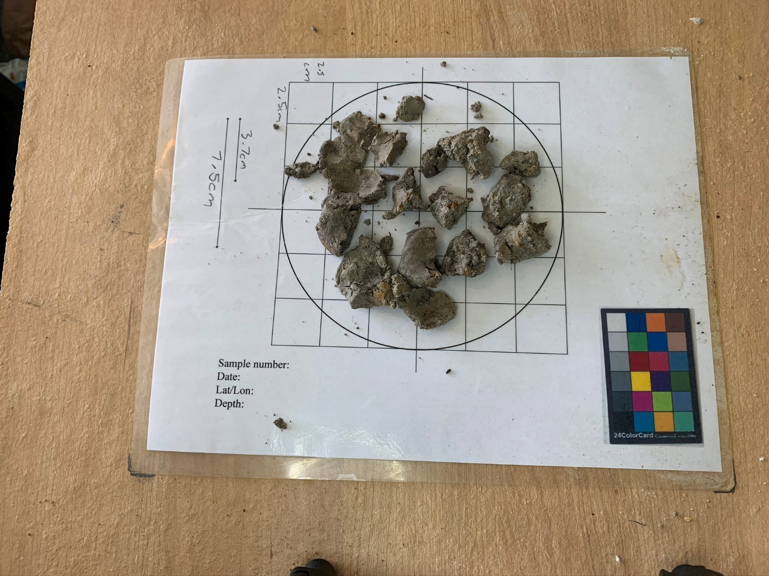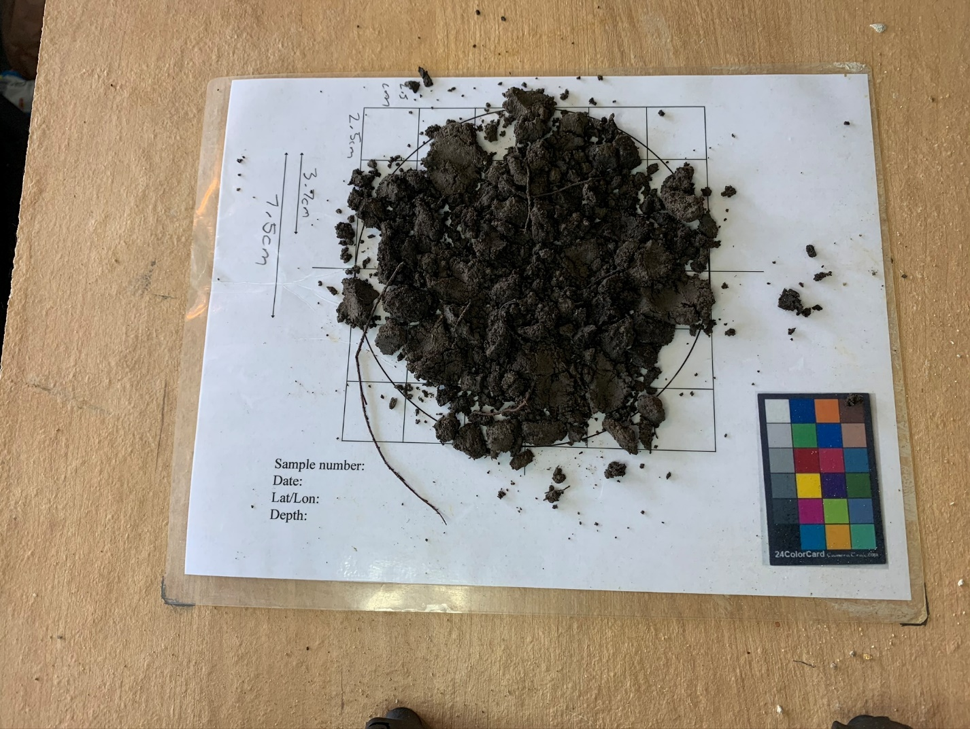

|  |  |
| --- | --- |
| 0cm – 8cm | Organic rich soil |
| 8cm – 20cm | Stiff, sandy clay, light gray with orange coloring |
| 20cm – 56cm | Dark brown and dark gray sandy clay |
| 56cm – 91cm | Light gray clayey sand |